Different topographic models are derived from 3D point clouds. A frequently used model is the Digital Terrain Model (DTM) describing the elevation of the ground surface.
In order to obtain a simple DTM, the lowest points within a defined neighbourhood can be used to represent the terrain.

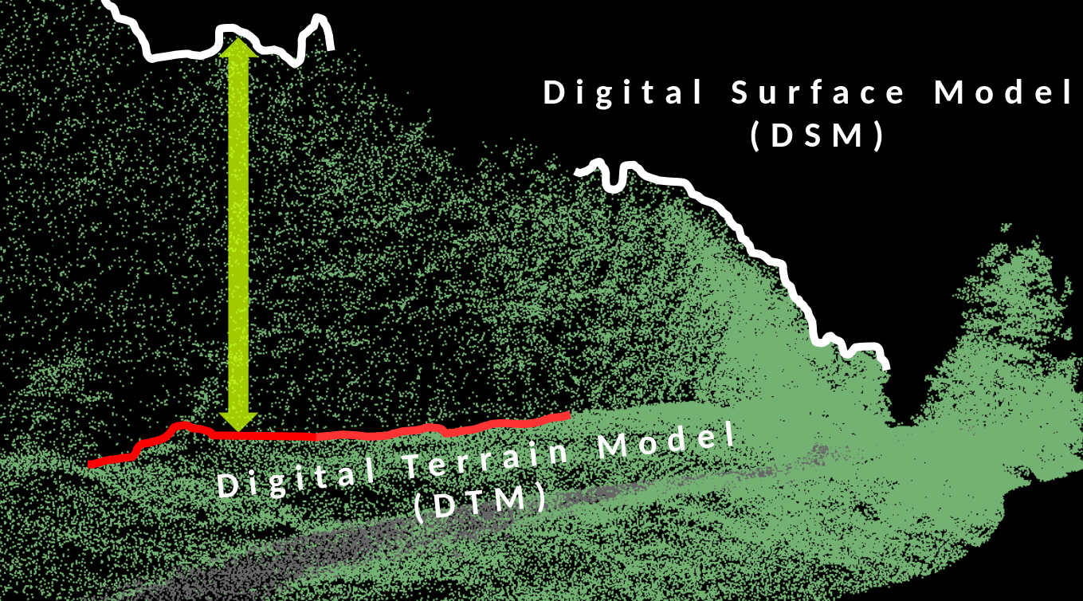

Survey area: Sandhausen
The 3D point cloud of an area next to Heidelberg was captured with TLS (Riegel VZ-400) by the LiDAR Research Group in 2011.

→ Instrument demonstrated in the course

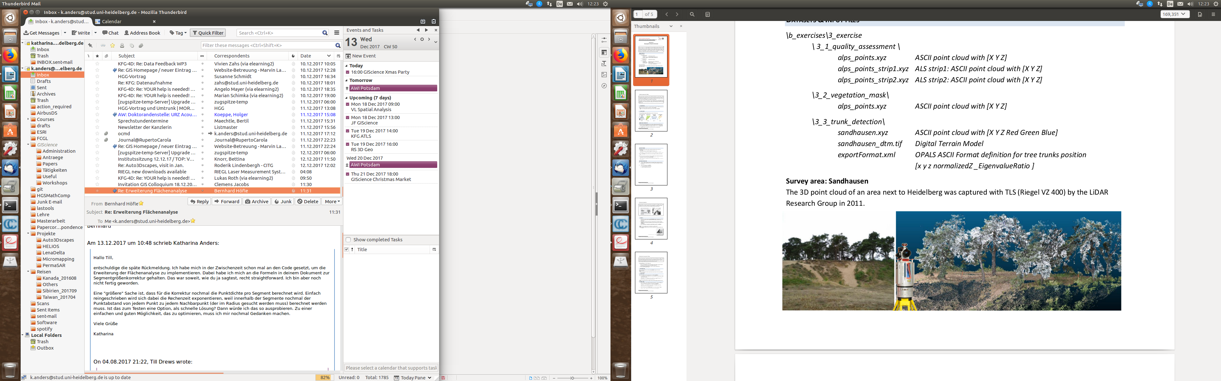
Point cloud extract:
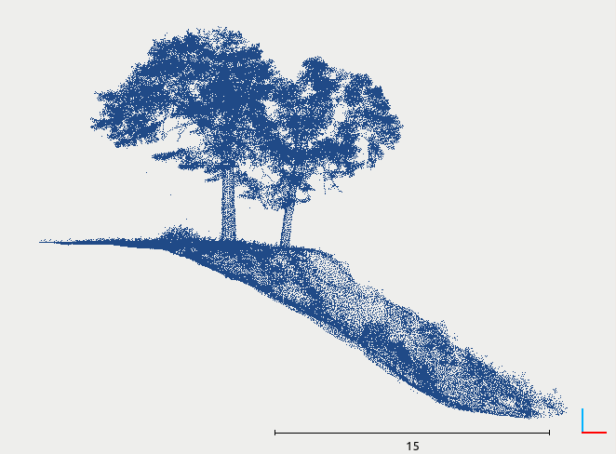
Format: space-separated ascii file of 3D coordinates (xyz)

